

AuditDoc – AI Powered Document Audit System

A Detailed Project Report
Submitted to : Dabasish Sahoo
Submitted by : Javed Hussain (10300323066)
Khushi Kumari (10300323068)
Team Name : J&K
Course: Advanced Python with ML and Cloud Computing
Abstract
AuditDoc is an AI-powered document auditing system designed to automate document analysis, extract structured insights, detect anomalies, and generate intelligent reports. The system integrates a Flask backend with a modern React frontend to deliver a seamless full-stack solution. This project demonstrates practical implementation of AI logic, REST APIs, and UI/UX design principles in real-world document processing applications

Introduction
In today’s world, almost every organization works with a large number of digital documents such as invoices, reports, contracts, and financial records. Managing and verifying these documents is an important task because even a small mistake can lead to financial loss, compliance issues, or operational problems. Traditionally, document auditing is done manually, where a person carefully checks every detail. However, this process takes a lot of time, requires significant effort, and is still prone to human error.
To solve this problem, I developed AuditDoc – an AI Powered Document Audit System. The main idea behind this project is to automate the process of document analysis using intelligent backend processing combined with a modern and user-friendly interface. The system allows users to upload a document through a web application, after which the backend processes the document, extracts important information, checks for possible inconsistencies, and generates a structured audit report.
AuditDoc is built using React and Tailwind CSS for the frontend and Python with Flask for the backend. The frontend provides an interactive dashboard where users can view insights, confidence scores, and structured JSON outputs in a clear and organized way. The backend handles the core processing logic and ensures that the output is accurate and meaningful.
This project not only focuses on automation but also on user experience. The interface is designed to be simple, clean, and visually informative, making it easy for users to understand audit results. Additionally, the system is modular and scalable, meaning it can be improved further with features like OCR integration, database storage, authentication systems, and cloud deployment.
Through this project, We aimed to demonstrate practical knowledge of full-stack development, API integration, intelligent data processing, and modern UI design. AuditDoc reflects how AI-based systems can simplify complex manual tasks and improve efficiency in real-world applications.

Objectives
The primary objective of developing AuditDoc – AI Powered Document Audit System is to simplify and automate the process of document auditing. Instead of relying on manual verification, this project aims to introduce an intelligent and structured system that can analyze documents efficiently and generate meaningful audit results.
The key objectives of this project are:
- To design and develop a full-stack web application for document auditing.
- To automate the extraction of important information from uploaded documents.
- To generate structured and organized outputs in JSON format and TXT format.
- To calculate and display a confidence score for audit reliability.
- To detect inconsistencies or missing information within documents.
- To create a clean, interactive, and user-friendly dashboard interface.
- To ensure smooth communication between frontend and backend using REST APIs.
- To build a scalable architecture that can support future enhancements.
Another important objective of this project is to apply practical knowledge of technologies such as React, Flask, API integration, and structured data processing in a real-world scenario. Through AuditDoc, the goal is not only to automate document analysis but also to demonstrate how intelligent systems can improve efficiency, accuracy, and productivity in organizations.

System Architecture
The architecture is divided into three main layers:
- Frontend Layer (User Interface)
- Backend Layer (Processing Engine)
- Output & Visualization

1. Frontend Layer (React + Tailwind CSS)
The frontend is developed using React (Vita) and styled using Tailwind CSS. This layer is responsible for:
- Allowing users to upload documents
- Sending the document to the backend via REST API
- Displaying structured results
- Showing confidence scores and insights
- Providing an interactive dashboard experience
The frontend includes components such as:
- Upload Card
- Output Panel
- Confidence Bar
- JSON Viewer
- TXT viewer

2. Backend Layer (Flask + Python)
The backend is built using Flask, a lightweight Python web framework. This layer acts as the core processing engine of the system.
Its responsibilities include:
- Receiving the uploaded file from the frontend
- Processing the document using predefined intelligent logic
- Extracting structured information
- Detecting anomalies or missing fields
- Generating a structured JSON response
- Calculating a confidence score

3. Output & Visualization Layer
After processing, the backend returns a structured JSON response and also in the TXT format to the frontend. This output includes:
- Document type
- Extracted fields
- Confidence score
The frontend then visualizes this data using interactive UI elements such as:
- Confidence bar graph
- Structured result cards
- JSON viewer panel
- TXT viewer panel

Technology Stack
- Frontend: React (Vita)
Tailwind CSS
JavaScript
- Backend: Python
Flask
- Data Format: JSON and TXT

- Communication: REST API

- Development Tools: VS Code,
Git
GitHub
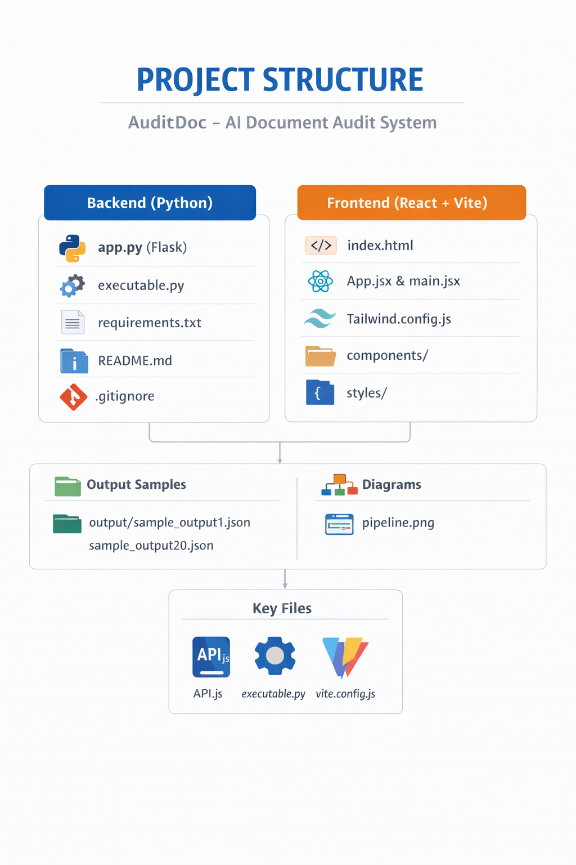

Advantages
The AuditDoc system offers several practical advantages that make it useful for real-world document processing and auditing tasks.

1. Reduced Manual Effort
AuditDoc significantly reduces the need for manual document verification. Instead of checking documents line by line, users can upload a file and receive structured results instantly.

2. Faster Processing
The system processes documents quickly and generates audit results in seconds, improving overall efficiency and saving valuable time.

3. Improved Accuracy
By using predefined intelligent logic, the system minimizes human errors and ensures consistent document analysis.

4. Structured Output Format
The output is generated in a clean and organized JSON format, making it easy to store, analyze, or integrate with other systems.

5. User-Friendly Interface
The React-based frontend provides a simple and interactive dashboard where users can clearly view extracted fields, confidence scores, and insights.

6. Modular and Scalable Design
The separation between frontend and backend makes the system easy to maintain, upgrade, and extend in the future.

7. Real-World Application
The project demonstrates practical implementation of full-stack development and intelligent document processing, making it suitable for enterprise-level adaptation.

Future Scope
Although AuditDoc successfully automates document auditing, there are several opportunities for further enhancement.

1. OCR Integration
Integrating Optical Character Recognition (OCR) would allow the system to process scanned PDFs and image-based documents.

2. Database Integration
Adding a database would allow storing audit history, user records, and structured outputs permanently.

3. Multi-User Authentication
Implementing login and role-based authentication would make the system secure and suitable for organizational use.

4. Cloud Deployment
Deploying the system on platforms such as AWS, Azure, or Render would enable global accessibility and scalability.

5. Advanced AI & Machine Learning
Future versions could include machine learning models for better anomaly detection, document classification, and predictive analytics.

6. Real-Time Analytics Dashboard
A more advanced dashboard with graphs and statistics could provide deeper insights into document trends and audit performance.

7. Multi-Format Support
Extending support to additional formats such as DOCX, Excel, and image files would increase usability.

Conclusion
AuditDoc is a full-stack AI-powered document audit system developed to automate the process of document analysis and reporting. It reduces manual effort, improves accuracy, and generates structured JSON outputs through an interactive dashboard.
The project successfully integrates React for the frontend and Flask for the backend, demonstrating practical implementation of API communication, structured data processing, and modern UI design. Overall, AuditDoc provides a scalable foundation for intelligent document auditing with strong potential for future enhancements.

